1.4 Types of Functions and Their Rate Of Change

Linear Functions

A linear function is a function represented by y = mx + b where m and b are constants.

Ex: y = 2x + 3

f(x) = 2x + 3

Ex: x² + y² = 1 (not a function). I cannot represent this in the form f(x) = .....
Ex: x² +1 = y, y = x² +1

Example
A car initially located 30 miles north of the Texas border, traveling north at 60 miles per hour is represented by the function f(x) = 60x + 30
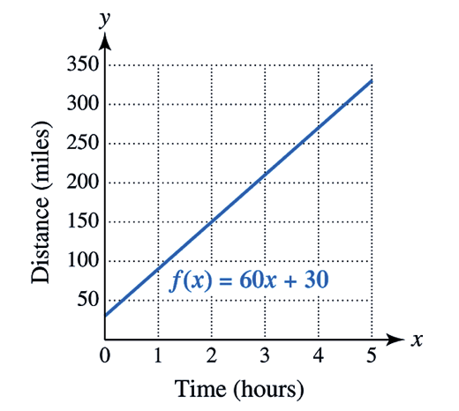

Question: What do you notice about the graph? What is f(0)?
Graph is increasing. f(0) = 30.

f(0) = 60(0) + 30 = 0 + 30 = 30.
f(0) "f of 0" means the output when the input is 0.

In a linear function f, the slope is constant , the value of f(x) always changes by an equal amount equal to m.

A linear function has a constant rate of change, which is equal to its slope.

Slope of a Line

The slope m of the line passing through the points (x₁, y₁) and (x₂, y₂) is
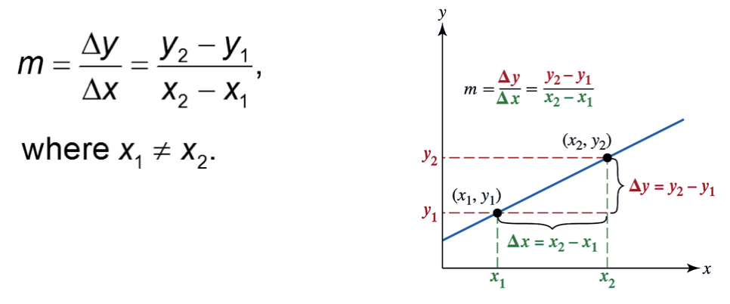

Activity: Draw a line with a positive slope, negative slope, and zero slope.

Positive Slope Negative Slope Zero Slope

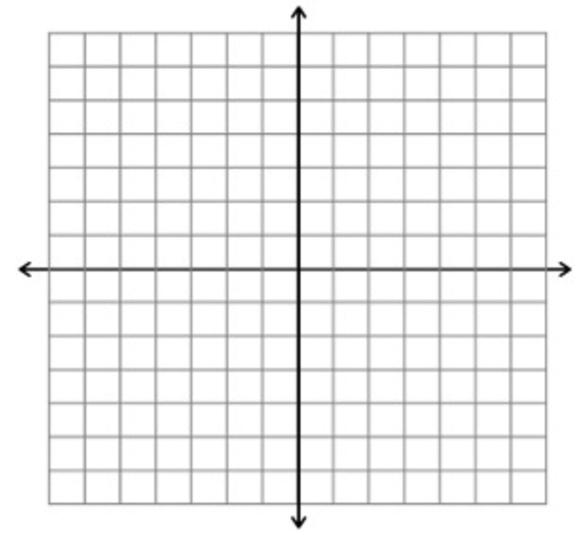

Example
Find the slope of the line passing through the points (−2, 3) and (1, −2). Plot these points together with the line. Explain what the slope indicates about the line. Is it increasing or decreasing?

Four Representations of a Function Revisited

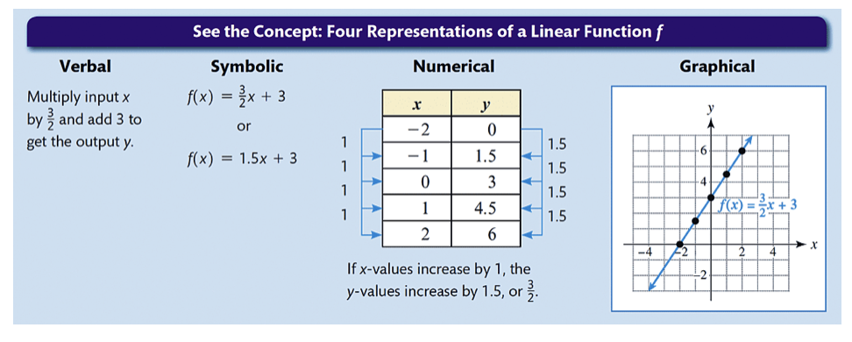

Zero of a Function
A zero of a function f(x) is a value a such that f(a) = 0. "The x-value of the point where the graph of the function intersects the x-axis" A linear function always has one zero. Another term for this is x-intercept.

The y-intercept is the point where the line intersects the y-axis. We can find this by substituting 0 into x (or the independent variable). f(x) = 3/2 x + 3
f(0) = 3/2 (0) + 3 = 0 + 3 = 3

Question: Find the zero and y-intercept of f(x) = 3x + 7.

y-intercept: f(0) = 3(0) + 7 = 7, so the y-intercept is 7.
the value of x when f(x) = 0.

3x + 7 = 0
- 7 -7

3x = -7
/3 /3

x = -7/3 (zero)

Non-linear Functions
If a function is not linear, then it is called a nonlinear function. The following are characteristics of a nonlinear function:

- no constant rate of change
- not a line
- can increase AND decrease on the domain
- no slope

Examples of Non-Linear Functions
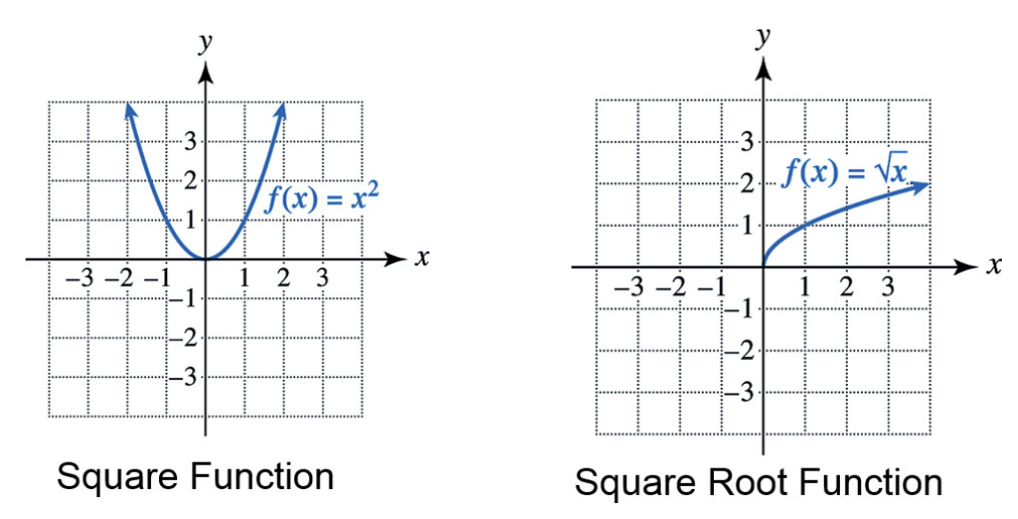

Increasing and Decreasing Functions

Suppose that a function f is defined over an interval I on the number line. If x₁ and x₂ are in I,
a. f increases on I if, whenever x₁ < x₂, f(x₁) < f(x₂);
b. f decreases on I if, whenever x₁ < x₂, f(x₁) > f(x₂).

Question: In plain English, what does this mean?

Example: Rock Music Sales

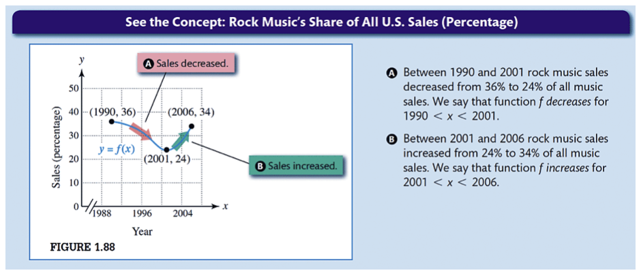

Average Rate of Change
Recall that only linear functions have a constant rate of change. For non-linear functions, we can find the average rate of change over an interval using the slope formula.

Example

Let f(x) = 2x². Find the average rate of change from x = 1 to x = 3.

Difference Quotient
The difference quotient is another way of stating average rate of change using different variables and notation. The difference quotient of a function f is an expression of the form
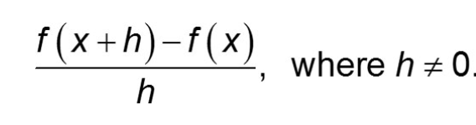

Example
Let f(x) = 3x − 2.
a. Find f(x + h)
b. Find the difference quotient of f and simplify the result.

Group Work

- In 1985, $95 billion was spent on advertising in the United States, and in 2005, $270 billion was spent. Find and interpret the slope of the line passing through (1985, 95) and (2005, 270).
- Given this function, write the interval for which this function is increasing/decreasing.
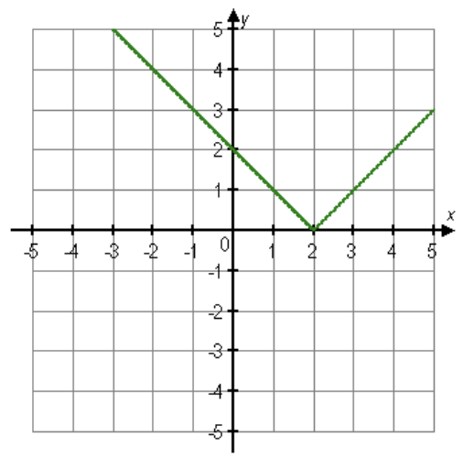

- The number of gallons of water remaining in a 100-gallon tank after x-minutes is given by G(x) = 100 – 5x.
  - Evaluate G(5) and interpret the result.
  - Find the slope of the graph of G. Interpret this slope as a rate of change.
- If f(1) = 12 and f(4) = −3, find the average rate of change of f from 1 to 4.
- Find the difference quotient for f(x) = –2x + 5.

